**KALLAM HARANADHAREDDY INSTITUTE OF TECHNOLOGY**



Domain: Salesforce Developer

Branch: Information Technology

Batch:8

|  |  |  |
| --- | --- | --- |
| Malempati Naga Rajitha | [218x1a1246@khitguntur.ac.in](mailto:218x1a1246@khitguntur.ac.in) | [malempatinagarajitha@gmail.com](mailto:malempatinagarajitha@gmail.com) |
| Dupati Ashok | [218x1a1209@khitguntur.ac.in](mailto:218x1a1209@khitguntur.ac.in) | [ashokdupati09@gmail.com](mailto:ashokdupati09@gmail.com) |
| Thimmareddy Vijay Kumar Reddy | [218x1a1261@khitguntur.ac.in](mailto:218x1a1261@khitguntur.ac.in) | [tvijaykreddy05@gmail.com](mailto:tvijaykreddy05@gmail.com) |
| Gumma Thirumala Raja | [218x1a1211@khitguntur.ac.in](mailto:218x1a1211@khitguntur.ac.in) | [tirumalarajagumma@gmail.com](mailto:tirumalarajagumma@gmail.com) |

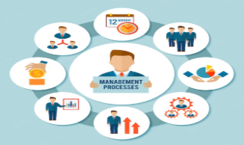

**Project Title: Streamlined Employee Detail Management**

**STREAMLINED EMPLOYEE DETAIL MANAGEMENT**

**1.Project Overview**

Streamlined Employee Detail Management using CRM is a comprehensive and efficient system designed to effectively manage and organize employee information within an organization. This system leverages Customer Relationship Management (CRM) principles and tools to centralize and streamline employee data, providing a robust platform for HR professionals and managers to handle various aspects of employee details.

**2.Objectives**

**Business Goals:**

1. Improve data accuracy: Ensure employee data is accurate, up-to-date, and consistent across all systems.

2. Enhance employee experience: Provide a user-friendly and streamlined process for employees to manage their personal details.

3. Increase operational efficiency: Automate manual processes and reduce administrative burdens on HR and management teams.

**Specific Outcomes:**

1. Develop a centralized employee database: Design and implement a single, unified database to store all employee details.

2. Implement a self-service portal: Create a user-friendly portal for employees to update their personal details, view benefits, and access company information.

3. Automate data validation and workflows: Develop automated processes to validate employee data, detect errors, and trigger workflows for approvals and updates.

**3. Salesforce Key Features and Concepts Utilized**

|  |  |
| --- | --- |
| * Salesforce * Object * Tabs * The Lightning App * Fields * Email Templates * Users * Approval Process * Flows * User Adoption * Reports * Dashboards * Apex   **4. Detailed Steps to Solution Design** |  |

**Object Creation**

To create an object:

1. From the setup page >>> Click on Object Manager >>> Click on Create >>> Click on Custom Object.

2.  Enter the label name "Employee"

3. Plural label name "Employees"

4. Enter Record Name Label and Format

* Record Name: Employee Name
* Data Type: Text

5. Click on Allow reports and Track Field History and Allow Activities.

6. Allow search >>> Save.

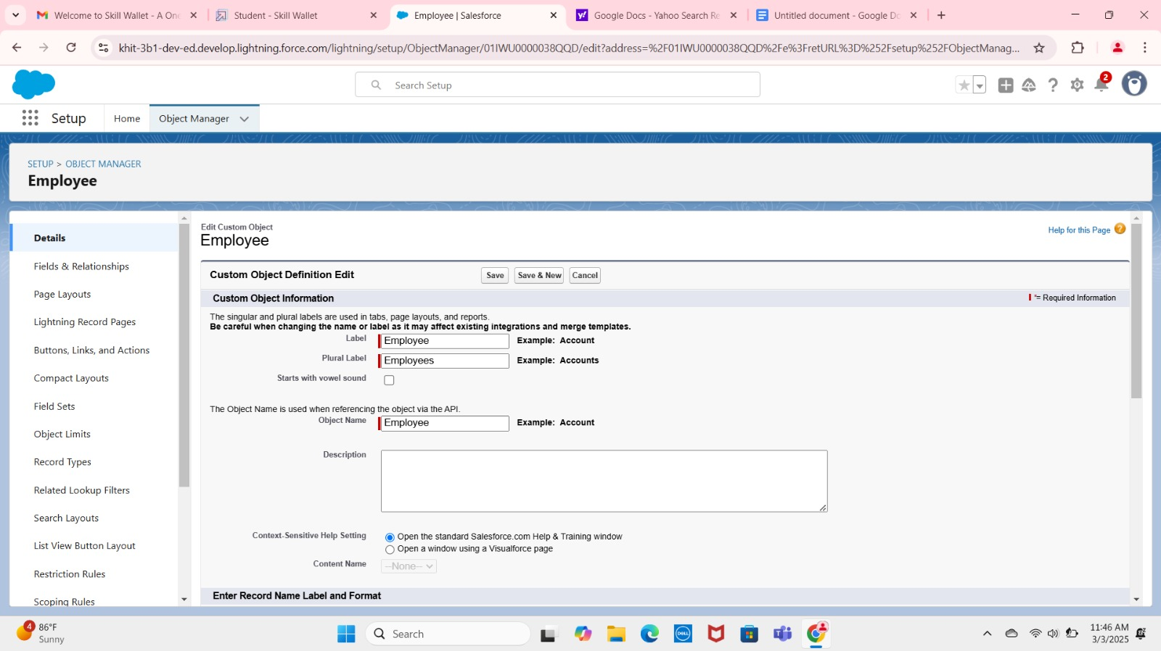

In the similar way Create the objects with the names Organization, Health Insurance, Leave.

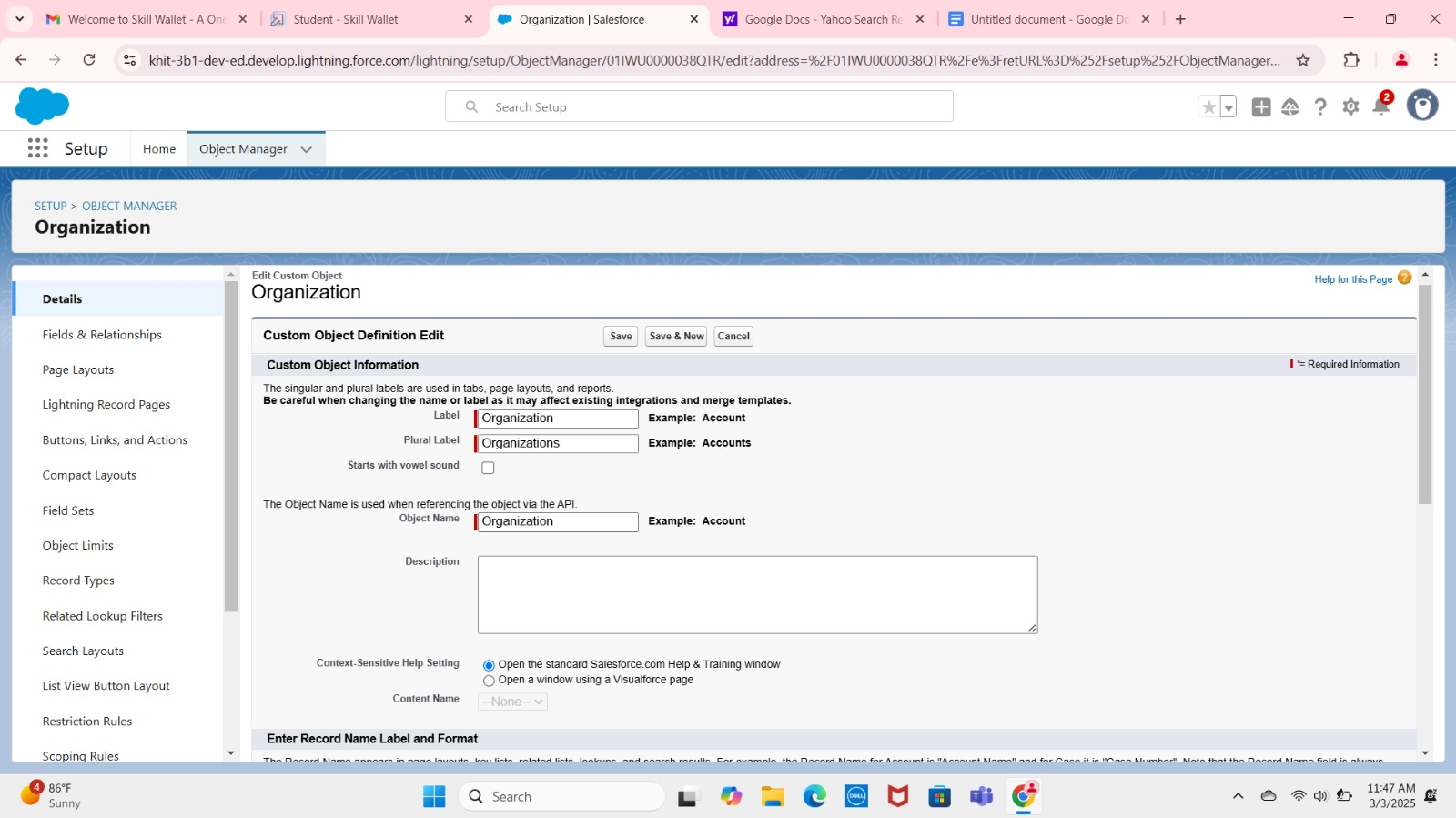

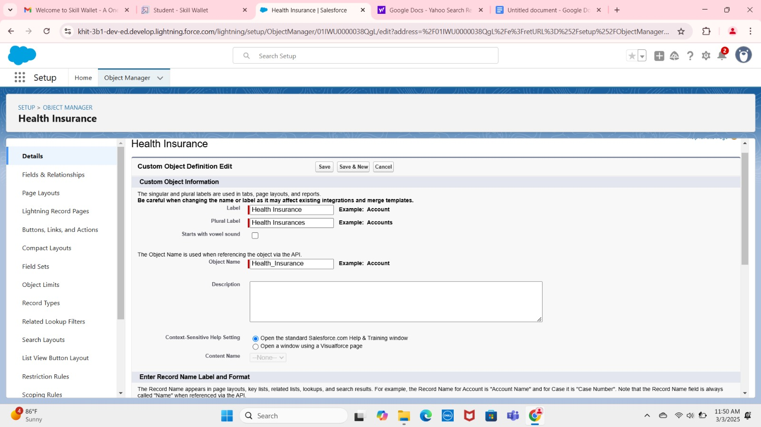

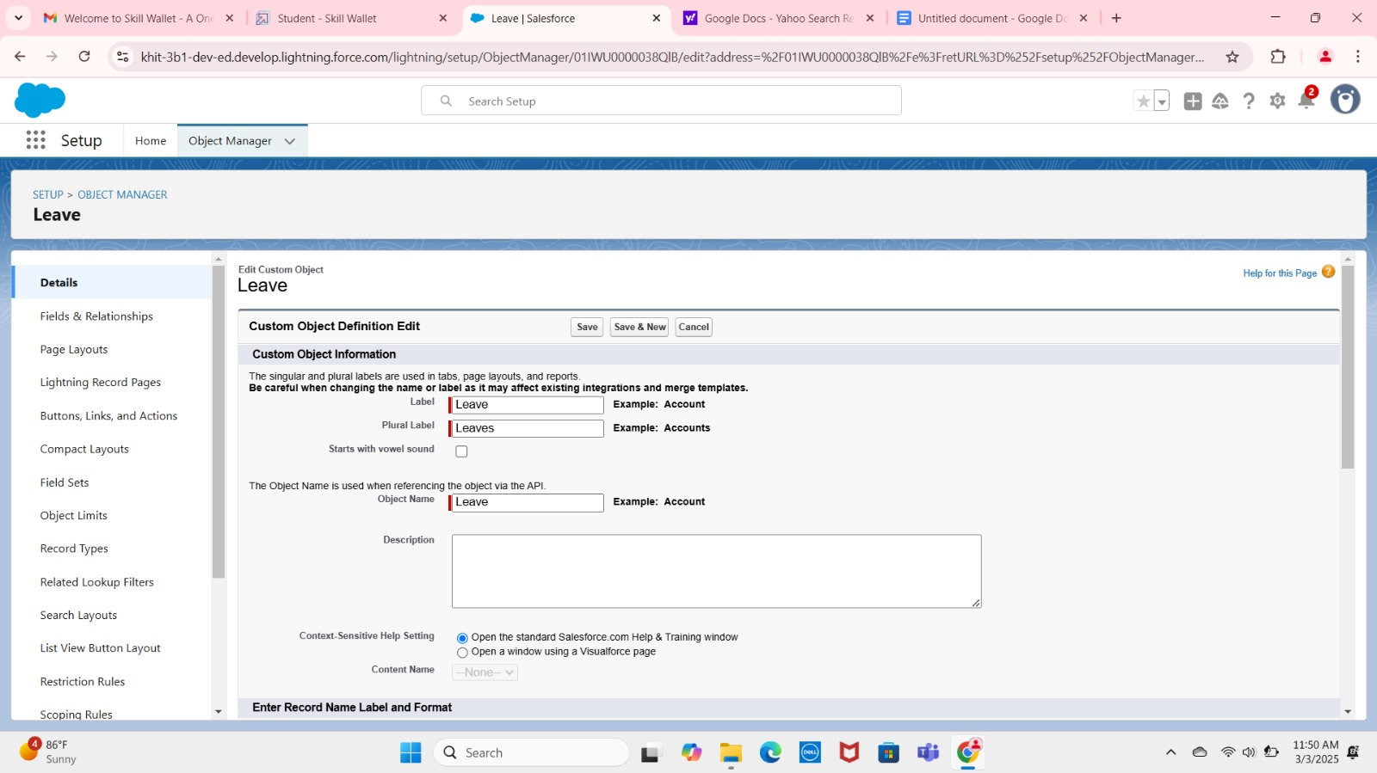

**Tabs Creation**

Go to setup page >>> type Tabs in Quick Find bar >>> click on tabs >>> New (under custom object tab)

1. Select Object (Employee) >>> Select the tab style >>> Next (Add to profiles page) keep it as default >>> Next (Add to Custom App) uncheck the include tab .
2. Make sure that the Append tab to users' existing personal customizations is checked
3. Click Save.

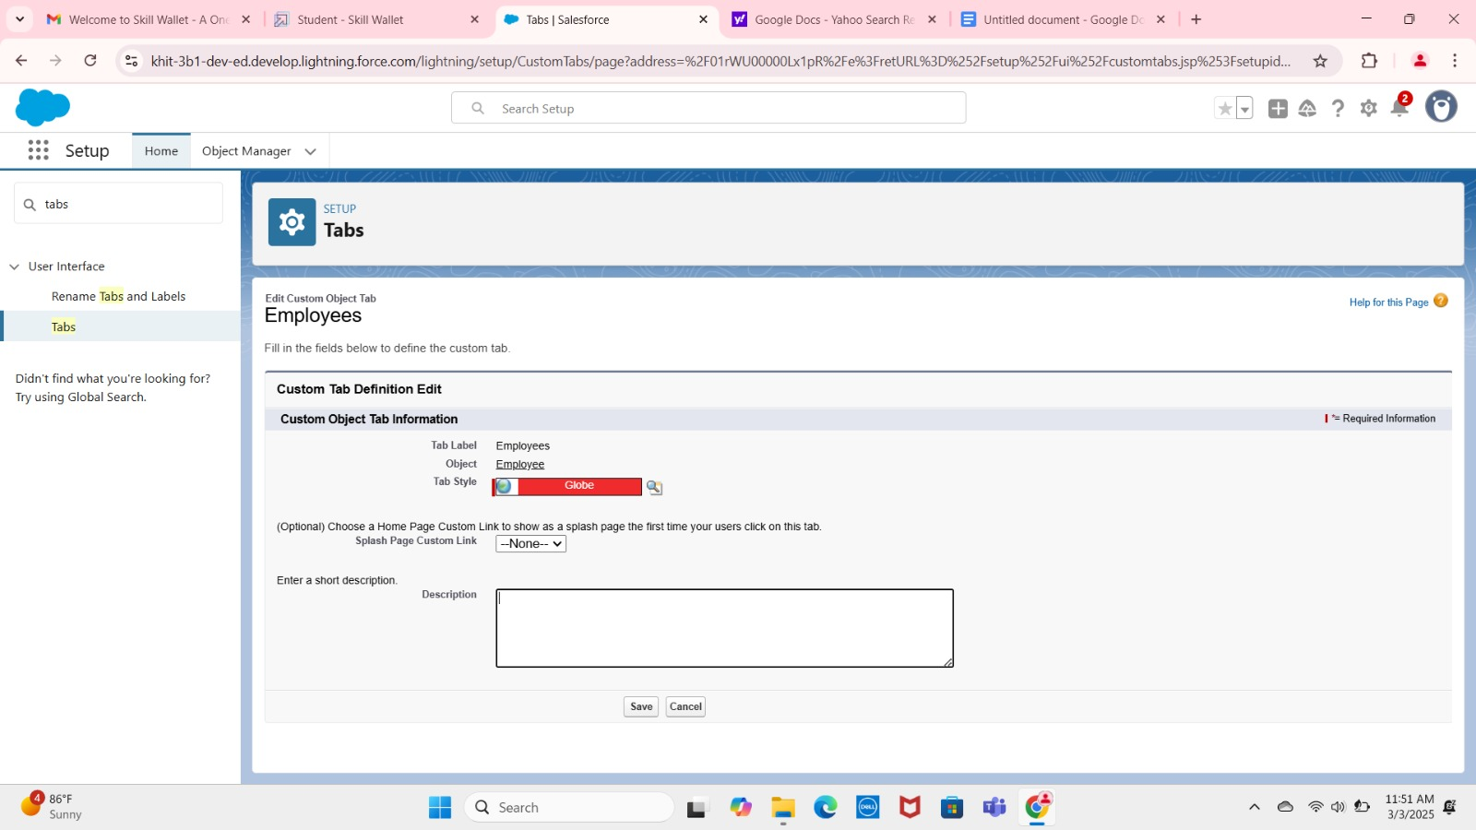

In the similar way Create the Tabs with the names Organization, Health Insurance, Leave.

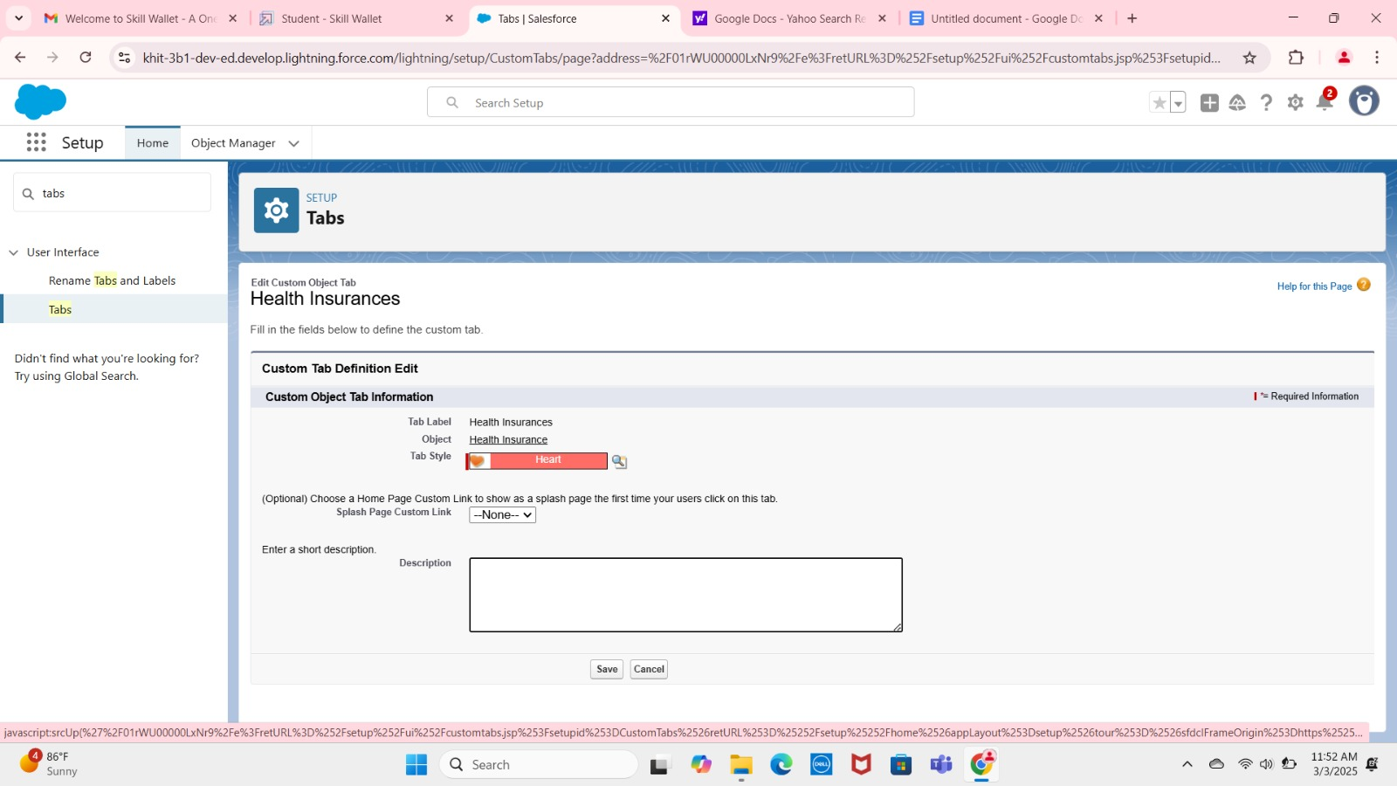

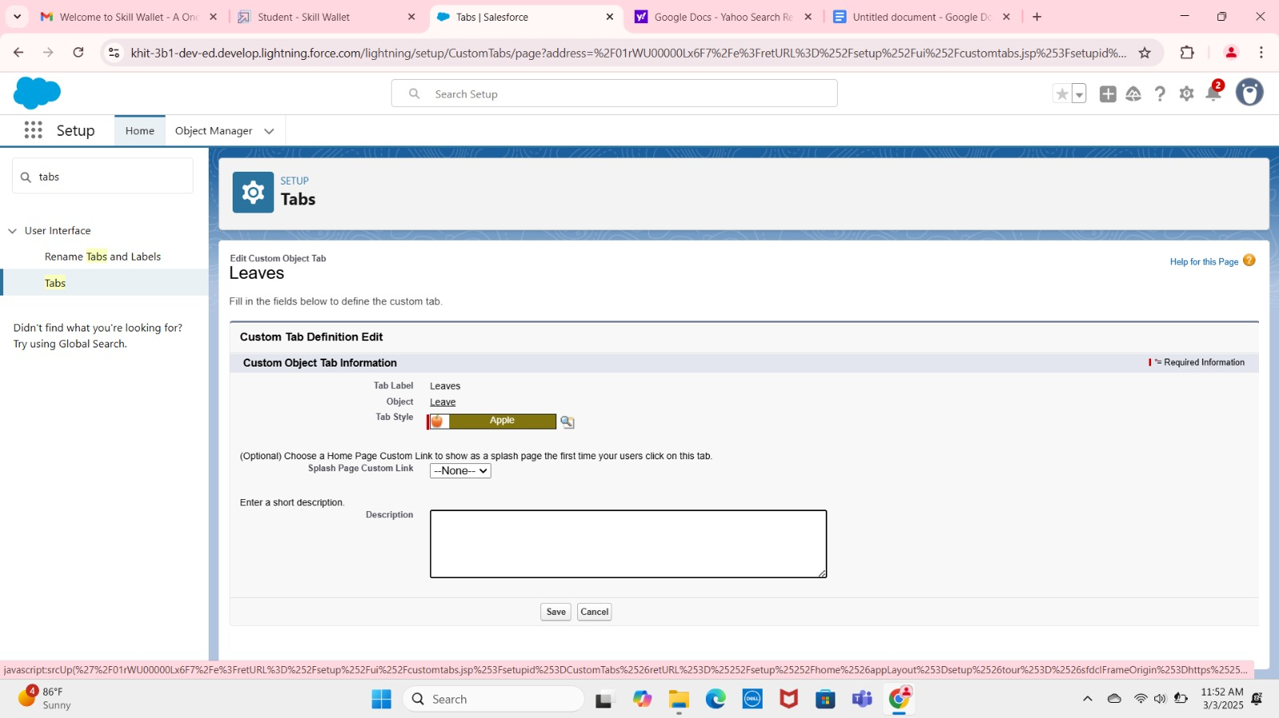

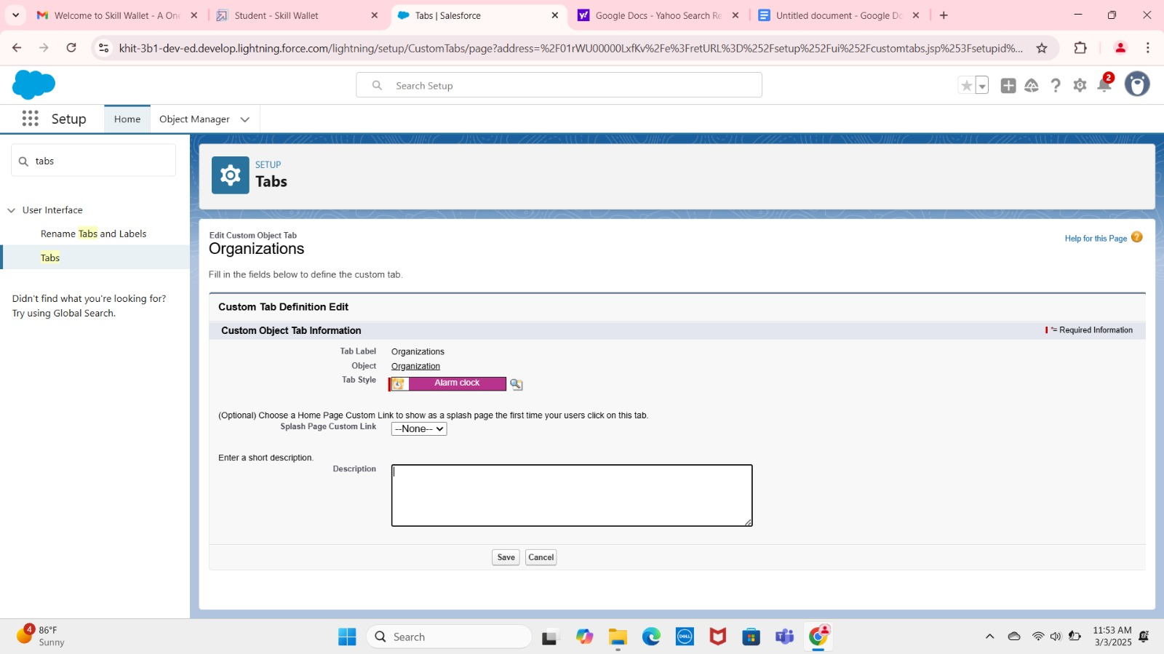

**Create a Lightning App**

1.Go to setup page >>> search “app manager” in quick find >>> select “app manager” >>> click on new lightning App.

    2. Fill the app name in app details as Employee Mapp >>> Next >>> (App option page) keep it as default >>> Next >>> (Utility Items) keep it as default >>> Next.

3. To Add Navigation Items: Select the items (Employee, Organization, Health Insurances, Leave) from the search bar and move it using the arrow button >>> Next.

To Add User Profiles:

 4. To Add User Profiles: Search profiles (System administrator) in the search bar >>> click on the arrow button >>> save & finish.

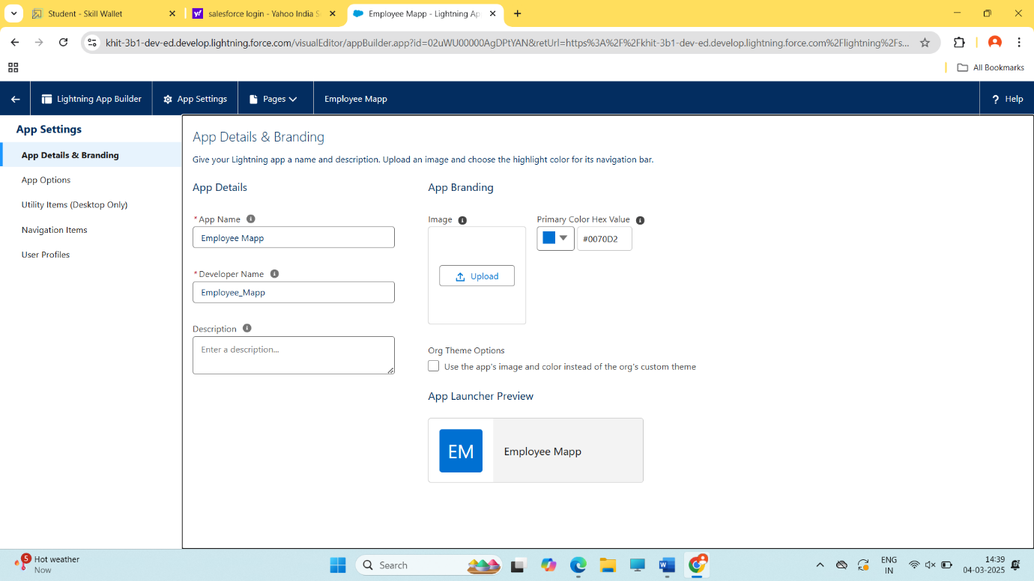

**Creating a Master-Detail Relationship**

1. Go to the setup page >>> click on object manager >>> From drop down click edit for Employee object.
2. Click on fields & relationship >>> click on New.
3. Select “Master-Detail relationship” as data type and click Next.
4. Select the related object Organization and click next.
5. Next>>>Next>>>Save

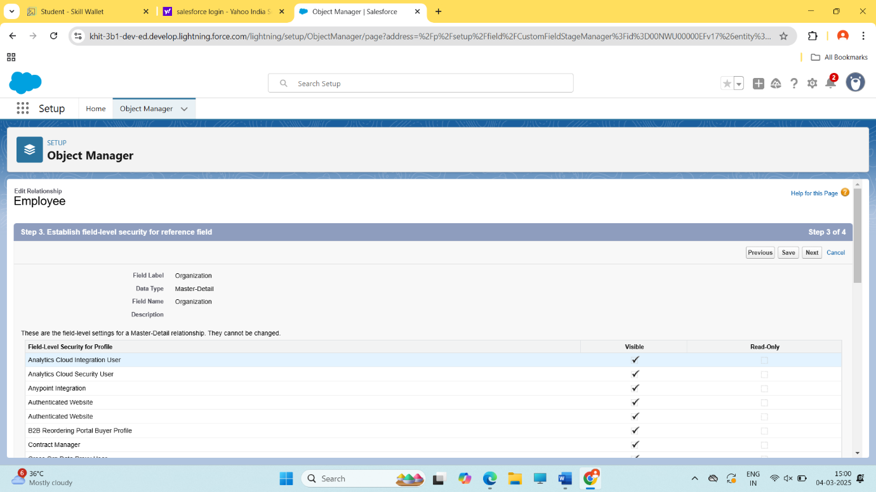

**Creating Lookup Relationship**

1. Go to the setup page >>> click on object manager >>> Click the Employee object.

 2. Click on fields & relationship >>> click on New.

 3. Click Lookup Relationship then next.

 4. Related to Health Insurance.

 5. Give Field Label as “Health Insurance Name” and click Next.  
 Next >>> Next >>> Save.

6. Go to the setup page >>> click on object manager >>> Click the “Leave” object.

7. Click on fields & relationship >>> click on New.

8. Click Lookup Relationship then next.

9. Related to Employee.

10. Related to Leaves.

11. Give Field Label as “Health Insurance Name” and click Next.

12.  Next >>> Next >>> Save.

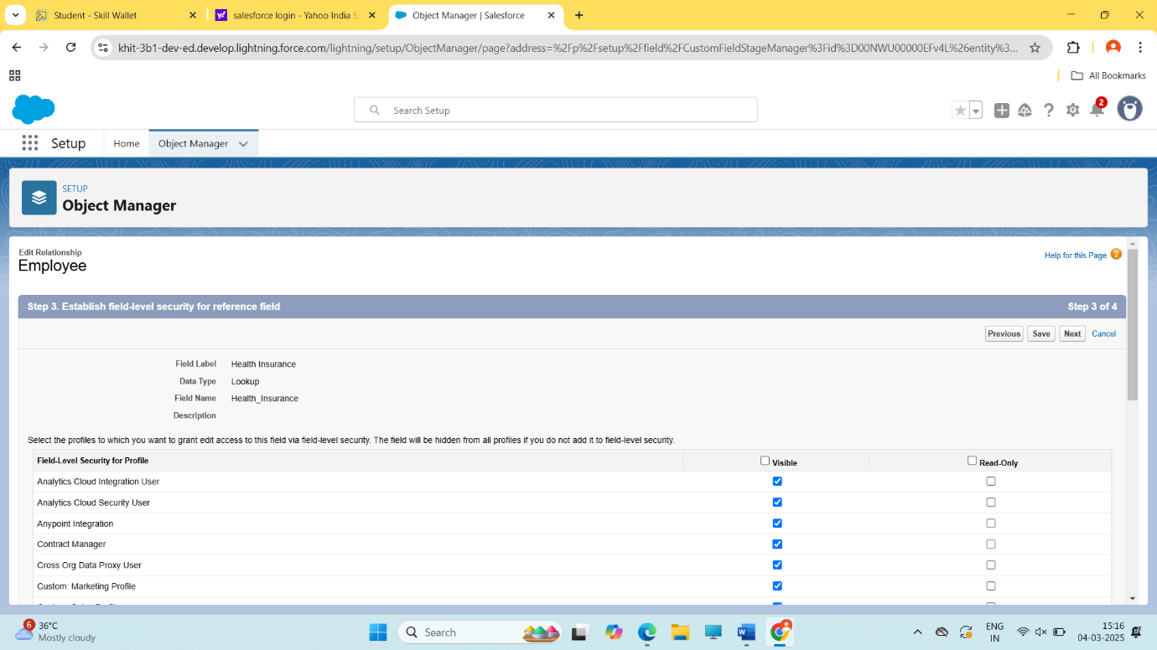

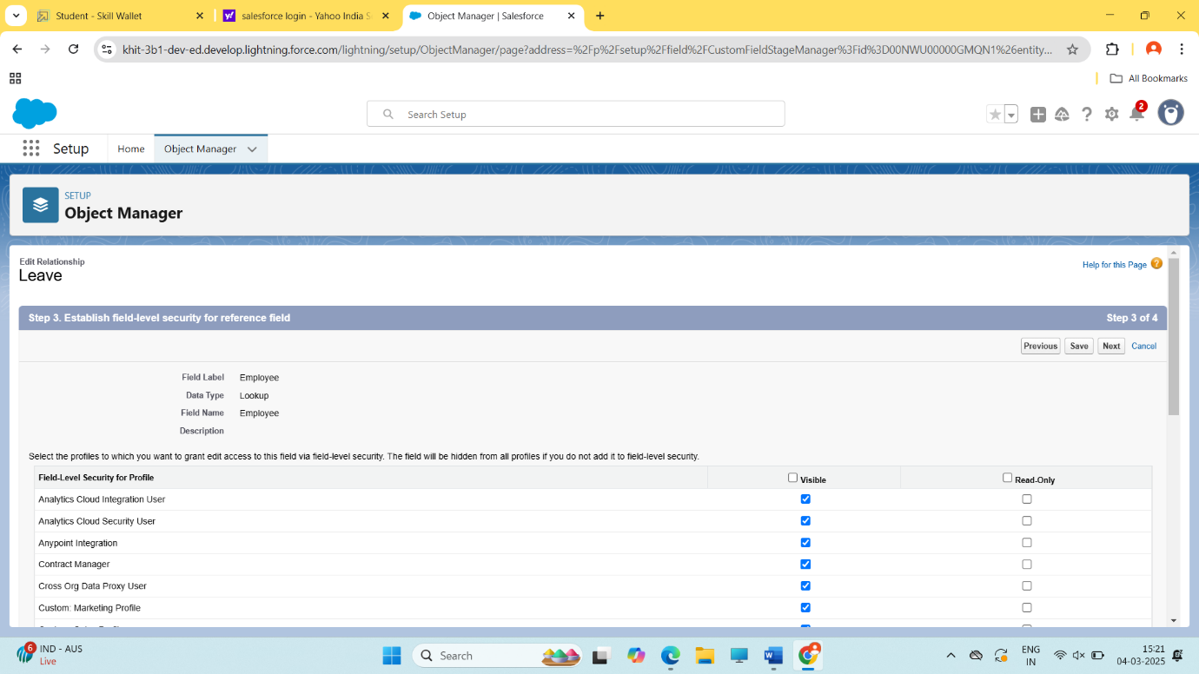

**The Fields Created in Employee Object**

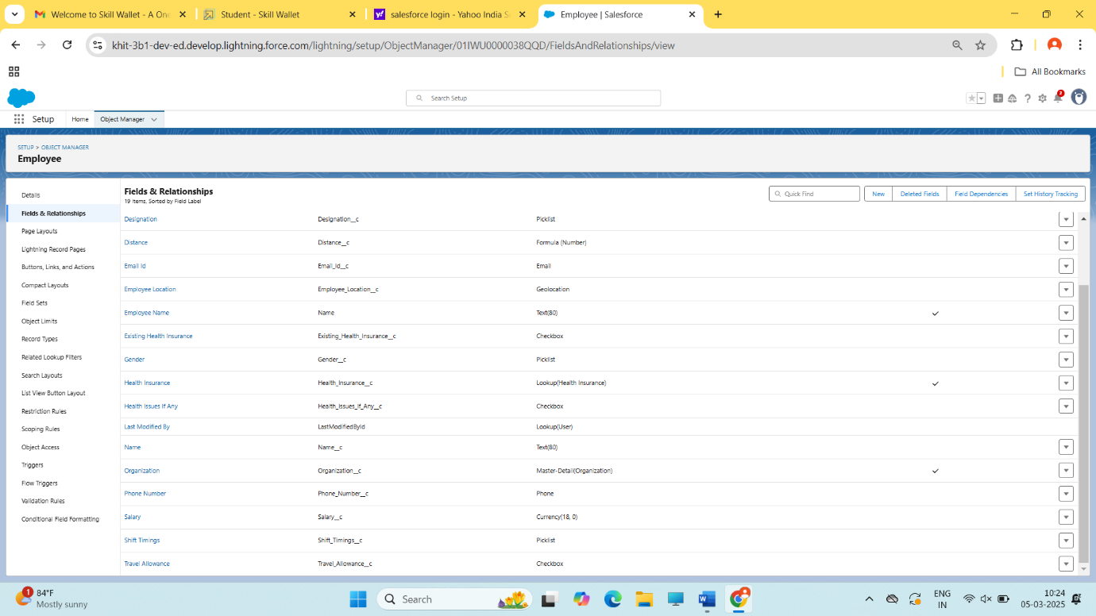

**The Fields Created in Organization Object**

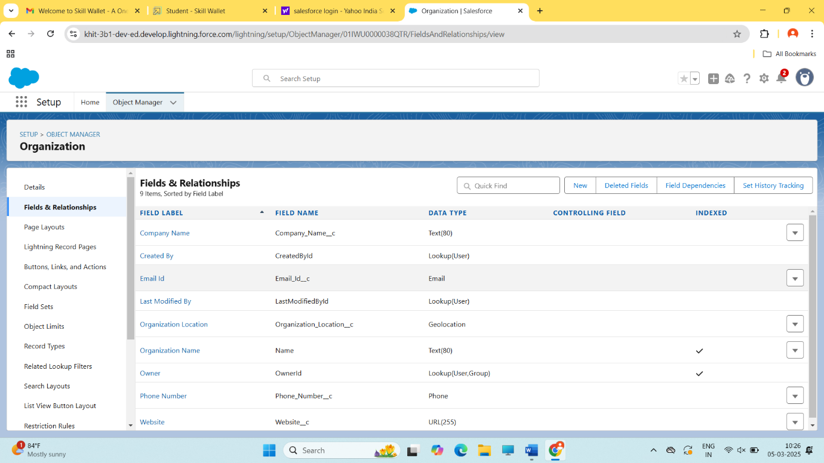

**The Fields Created in Health Insurance Object**

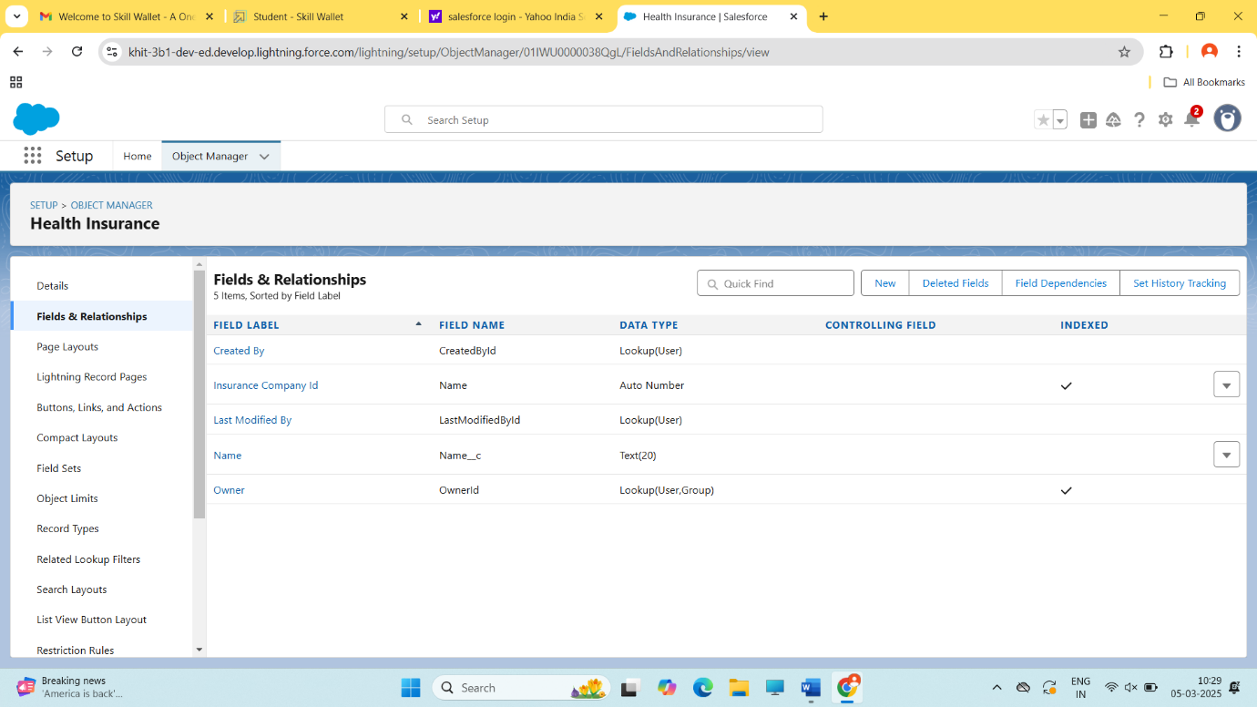

**The Fields Created in Leave Object**

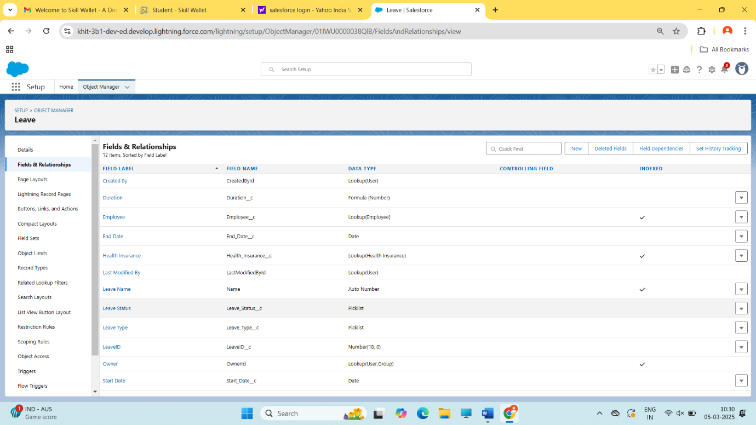

**Create Email Template For Emergency Leave Approval**

To create Email Template:  
1.  Go to App launcher >>> click on Email Template.  
2.  Click on “Email Templates” >>> New Email Template.  
3.  Email Template Name is “Emergency Leave Approved”  
4. Related Entity Type >>> Employee  
5.  Description “Your emergency leave was approved”.  
6.  Folder “Public Email Templates”.  
7.  Subject “Your Emergency leave was approved”  
8.  In the HTML text enter the given information and click save.

Dear {{{Employee__c.Name}}}

I hope this email finds you well. We wanted to inform you that your emergency leave request has been approved.

Please ensure that all pending tasks are delegated, and you have completed any necessary handovers before proceeding on your leave.

During your absence, if any urgent matters arise or if there is a need for any further assistance, please contact the Manager.

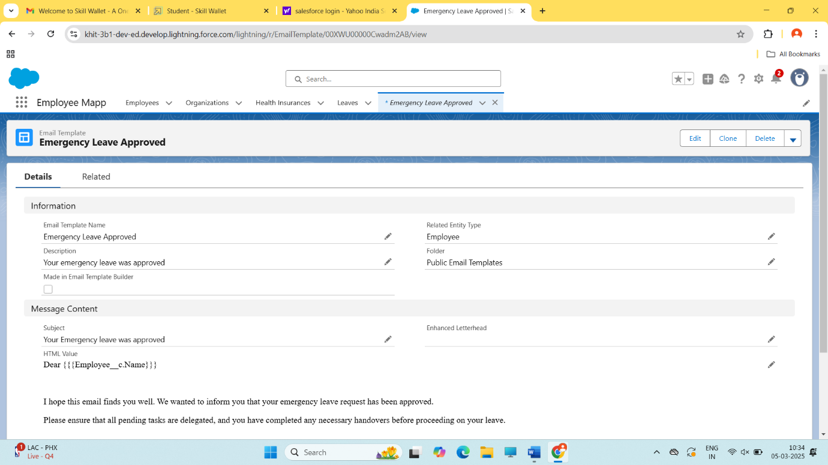

**Create User 1**

Go to setup >>> type users in quick find box >>> select users >>> click New user.

Fill in the fields

  1. First Name: Racheal

  2. Last Name: Marc

  3. Alias: Give a Alias Name

  4. Email id: Give your Personal Email id

  5. Username: Username should be in this form: text@text.text

  6. Nick Name: Give a Nickname

  7. Role: SVP, Human Resources

  8.User license: Salesforce Platform

  9.Profiles: Standard Platform User

 10. Save.

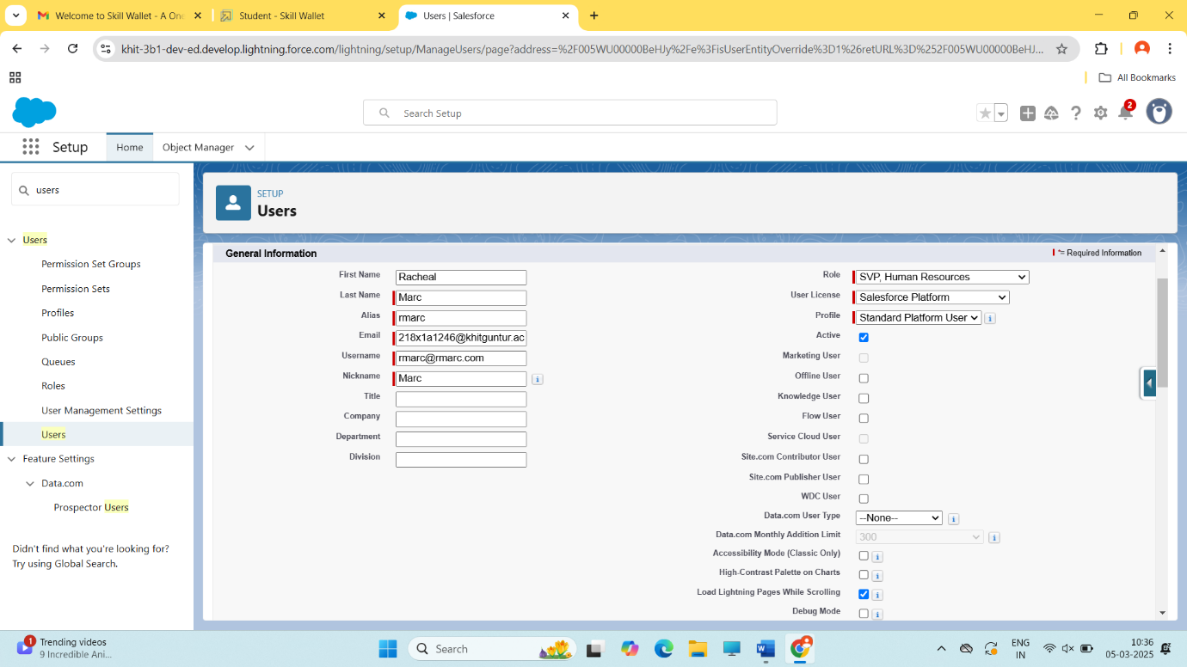

In the same way create user 2 with the name

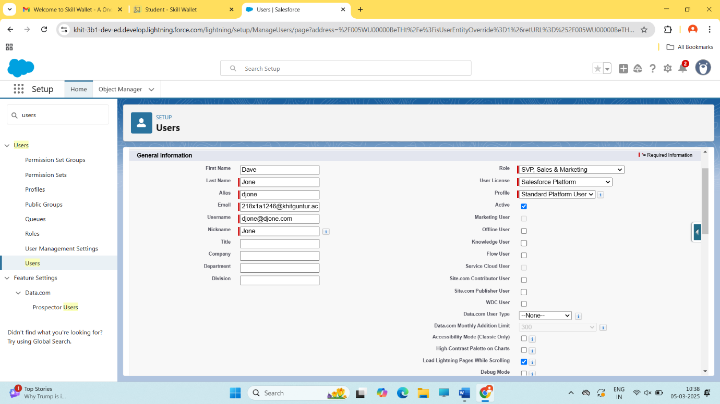

**Create Approval Process For Emergency Leave**

To create fields in an object:

1.Go to setup >>> Approval Processes in quick find bar >>> click on it.

2.Manage Approval Process For >>> “Leave” from the drop down.

3.Click on “Create New Approval Process” >>> Use standard setup wizard.  
4. Process Name “Emergency Leave Approval” >>> Click Next.

5. Field “Leave: Leave Type” >>> Operator: equals, Value >>> Click on the lookup filter icon and select “Emergency Leave”.  
6. Click insert field, then click Next.

7. Field “Leave: Leave Type” >>> Operator: equals, Value >>> Click on the lookup filter icon and select “Emergency Leave”.

8. Next Automated Approver determined by “Manager” from the drop down. Use approver field of leave owner should be marked as check.

9. Select the “Administrators ONLY can edit records during the approval process”. Then Next.

10. Under the Approval Assignment Email Template click in the lookup icon >>> Lightning >>> Public Email Templates “Emergency Leave Approved”. Then Next.

11. From the available fields select >>> Leave ID, and then add >>> Add it to the selected Fields. Similarly add the Owner, Leave, Type, Status. Then Next.

* Make sure Display approver history is checked.
* And under security settings check the “Allow approvers to access the approval page only from within the Salesforce application. (Recommended)” option.

12. Submitter type Search >>> Owner, Allowed Submitters >>> Leave Owner. Then Next.

* Make sure Allow submitters to recall approval requests is checked.
* Then click save.

13. Once you have saved your approval process, while on the same page click   the  approval process.

14. At the approval steps, Click on “New Approval Step”.

15. Enter the name as “Approver1” the unique name will automatically be updated. Then Next.

16. All records should enter this step. Then Next.

17. Automatically assign to approvers is to be selected. User: from the lookup give the user.

18. “Approve or reject based on the FIRST response” is to be selected. Then click save.

19.While on the same Approval Process page .Under the “Final Approval Action” click Add New from the drop down select  “Email  Alert”.

20. Description: Your  emergency leave request was approved. Unique name is auto populated.

21. Email Template, click the lookup option and  select Emergency Leave Approved.

22. Recipient Type : User, Selected Recipient : Leave Owner. Then click save.

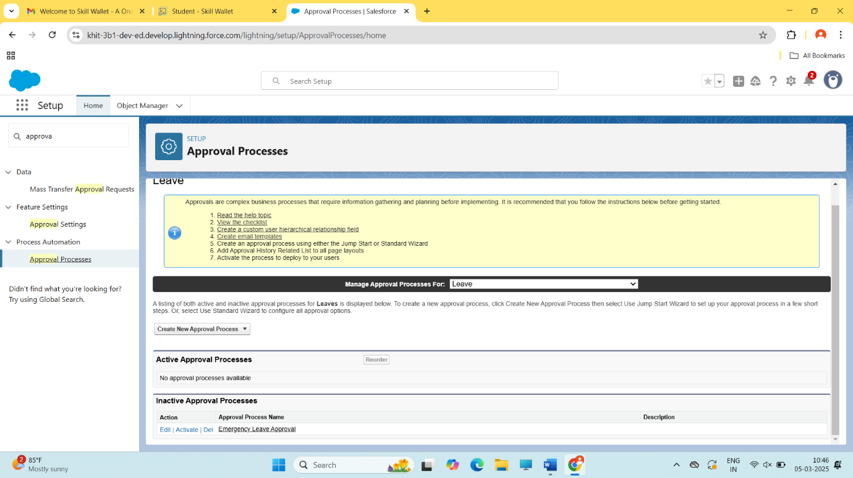

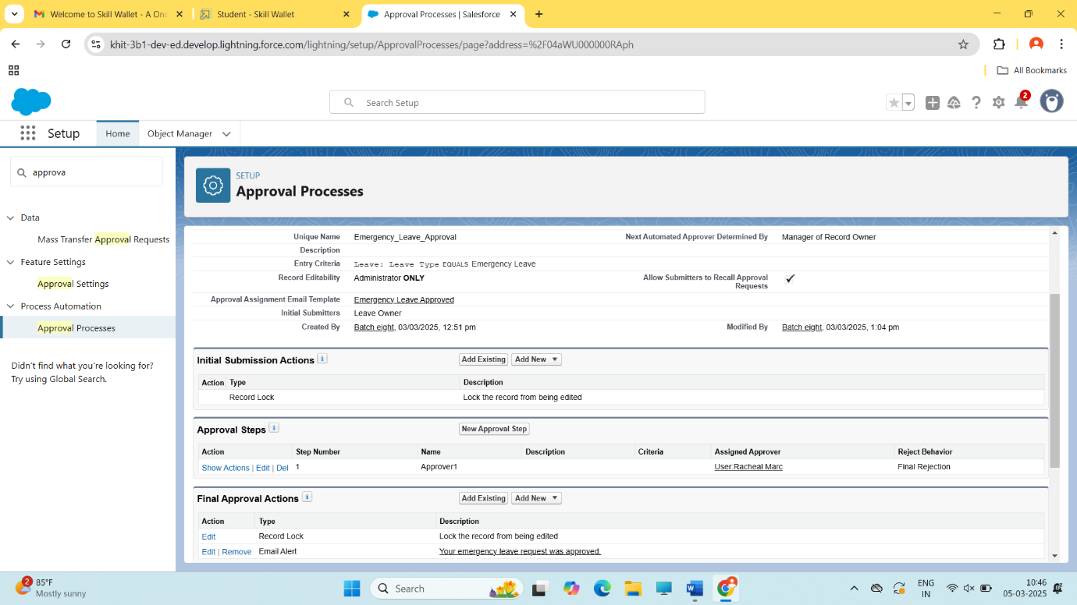

**Create Flow for Shift to start**

1. Go to setup >>> type Flow in quick find box >>> Click on the Flow and Select the New Flow.
2. Select the record Triggered flow. Click on create.
3. Under Object select ”Employee”. Click on  A record is created or updated. Actions and Related Records, Done.
4. Select Free Form Layout for the flow and then Click on the Manager option, You will find “New Resource”

      5. Select “Text Template”

    6. Then API name should be filled as “Email Body”, And enter the given details in it

{!Emailbody}

Just a quick note to inform you that your shift has now started. We're excited to have you on board and ready to make a positive impact today!

Should you need any support or have any questions during your shift, don't hesitate to reach out to your team members or supervisor.

Health Issues If Any: {!$Record.Health_Issues_If_Any__c}

Existing Insurance: {!$Record.Existing_Health_Insurance__c}

Travel Allowance: {!$Record.Travel_Allowance__c}

7. Click “New Resource” under manager.

8. Select “Text Template”

9. Then API name should be filled as “Subject”.And enter the given details in it (Hi this is to inform you that your  shift has just started.) Make sure it is “view as plain text”.

10. Click Done.

11. Drag the  “Action” element from the toolbox onto the screen.

12. Under Category dropdown select Email, Then in the action bar select “ Send Email ” action.

13. Give API name as “Shift Started”.

14. Change the toggle to “Include the Body” Select {!Emailbody} from the dropdown.

15. Change the toggle to “Include the Subject” Select{!Subject} from the dropdown.

16. Change the toggle for recipient address list to include. From the dropdown select “{!$Record.Email_Id__c}”

 17. And then click save, and click on activate.

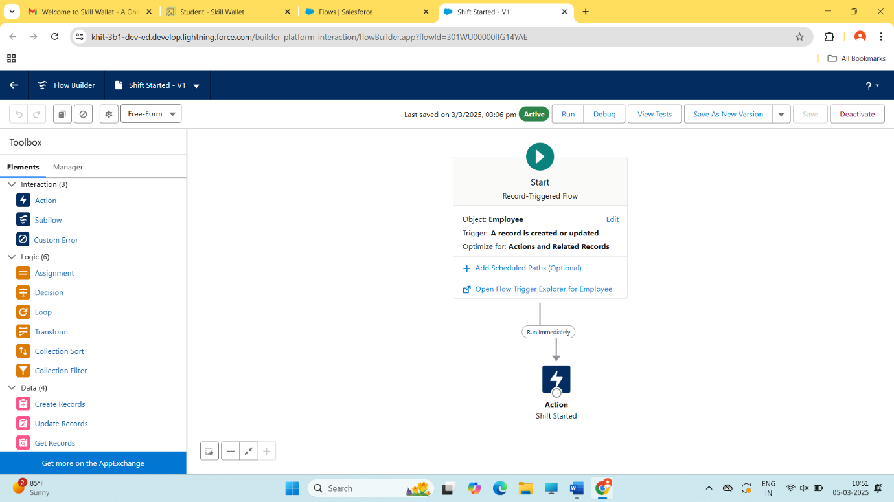

In the same create another flow with the name Email Alert.

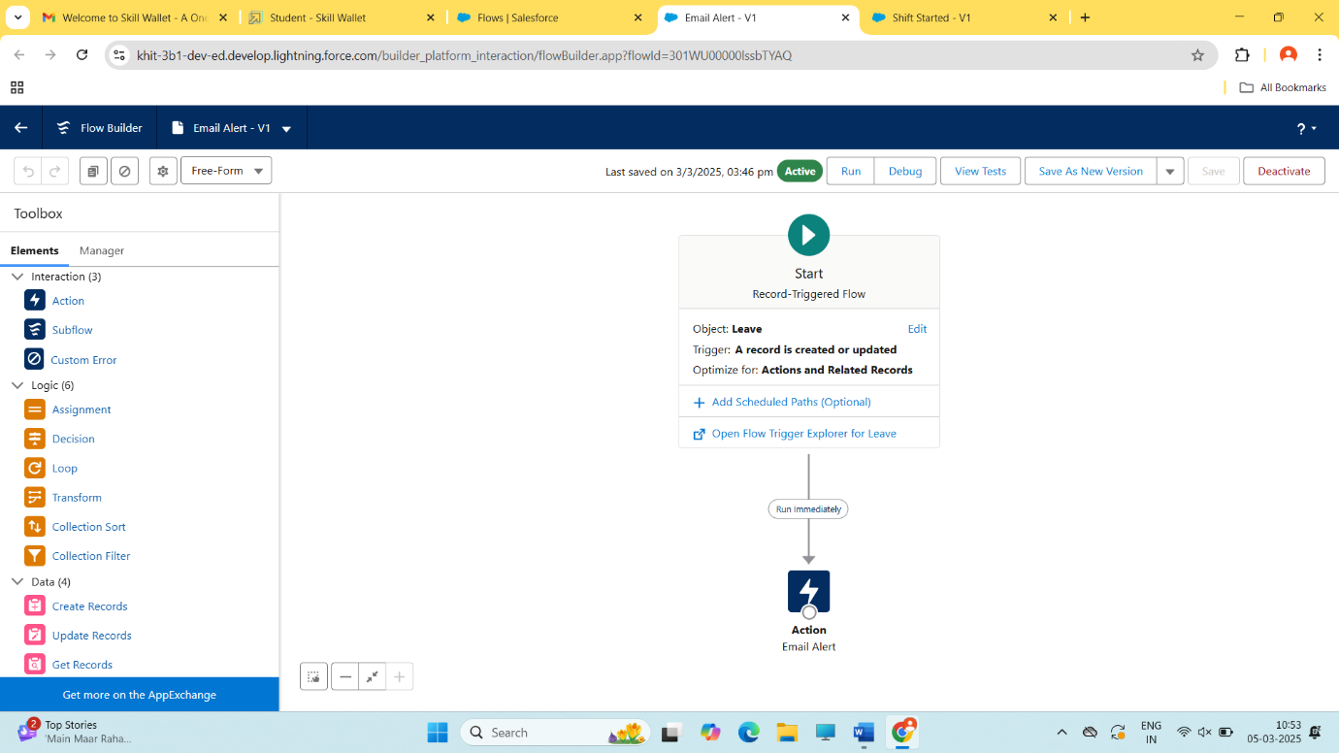

**User Adoption**

**Create Records for the Employee object**

1. Go to App Launcher >>> click on Employee Mapp.
2. Click on the employee Tab. Click on New.
3. Fill in the employee details.
4. Give the employee name, email, date of birth, gender, salary all the fields are to be filled including shift timings.
5. Make sure you fill the location in terms of latitude and longitude as shown below.
6. Then click save and new. (Similarly create more records in the employee object)

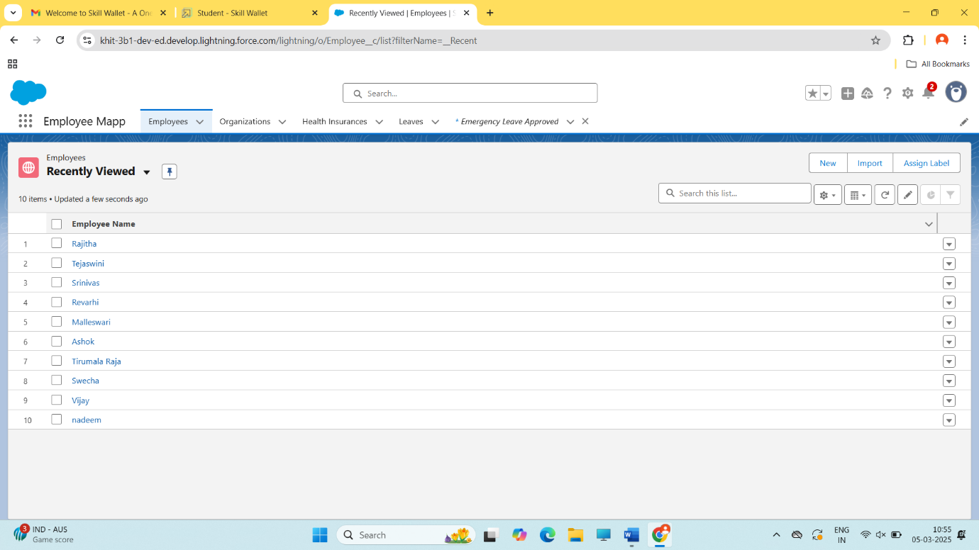

In the same way create records for Organization, Helath Insurance, and Leave Objects

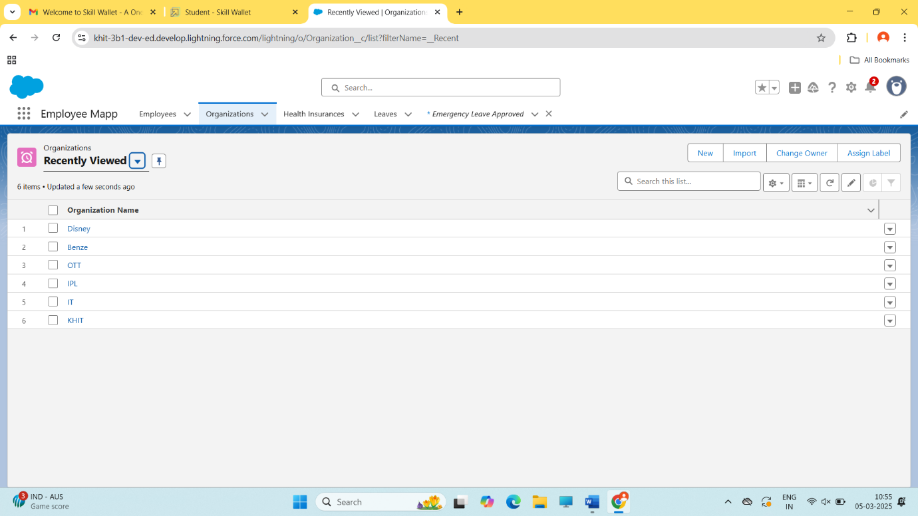

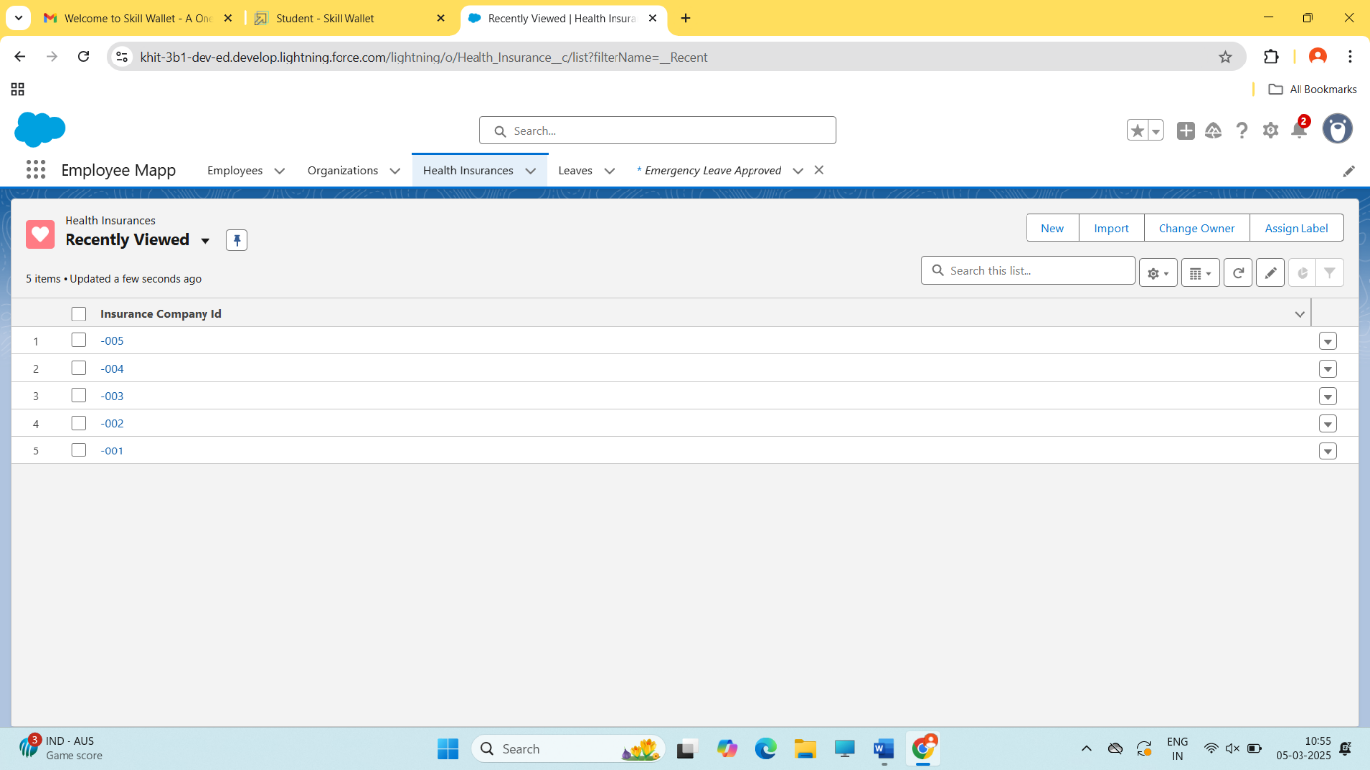

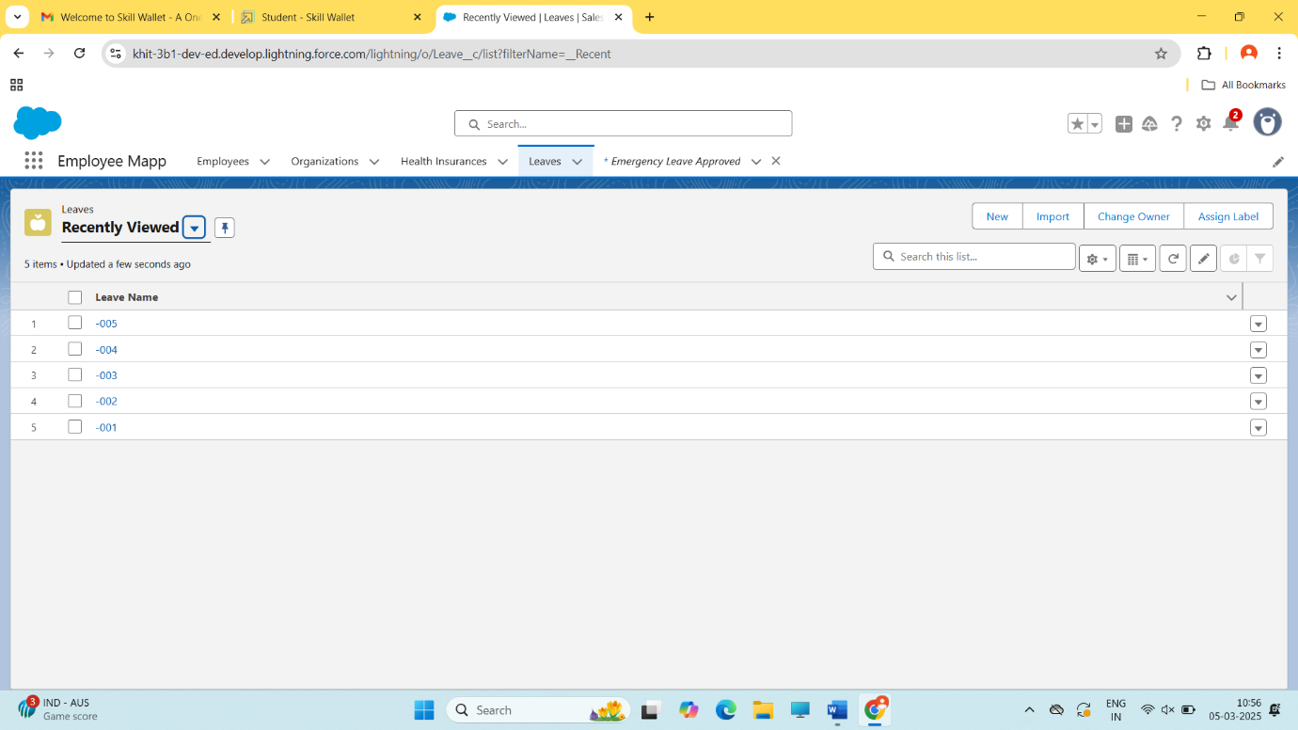

**Create Report**

1. Go to the app >>> click on the reports tab

2. Click New Report.

3. Select report type from category or from report type panel or from search panel >>>    click on start report.

4. Select report >>> Employees with Organizations with Travel Allowances , Then click on start report.

5. Once you click on start report you will see that the records you have created would be displayed.

6.Group the columns according to your preference from the dropdown as shown.

7. Save your report as Travel Allowance Report. And run it.

8. Similarly create a report for Organizations with Employees and Health Insurances and save it as “Employee and health insurances”.

9. Similarly create a report for Leave with employee and save it as “Employee leave details”.

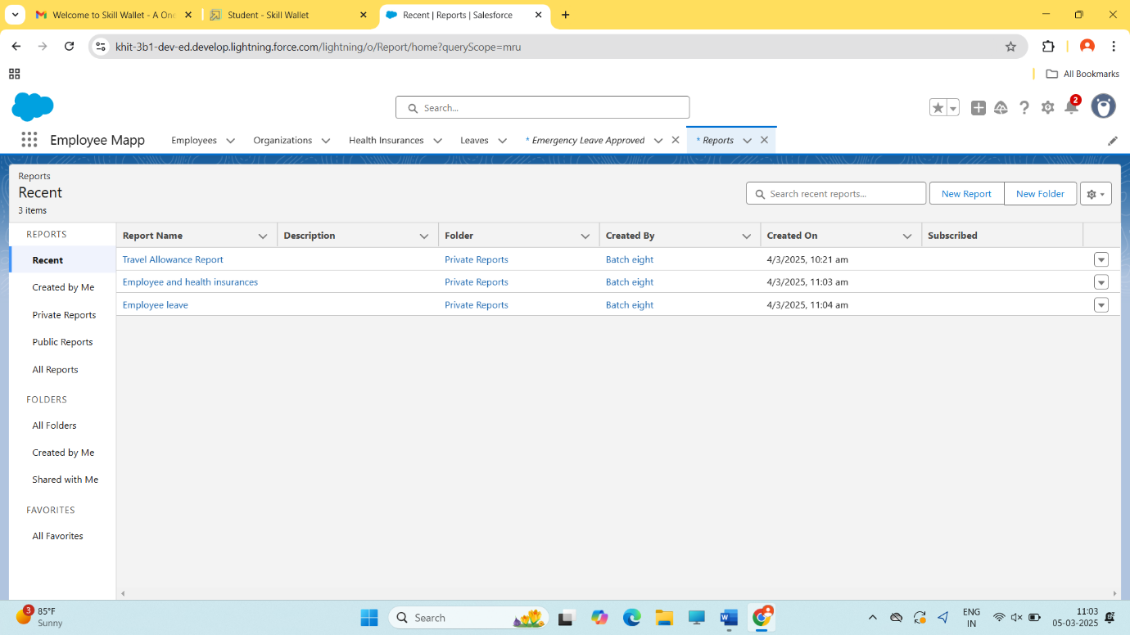

**Create Dashboard**

1. Go to the app >>> click on the Dashboards tabs.

2. Give a Name and click on Create.

3. Select add component.

4. Select a Report and click on select.

5. Add the component on the dashboard.

6. Click save then done.

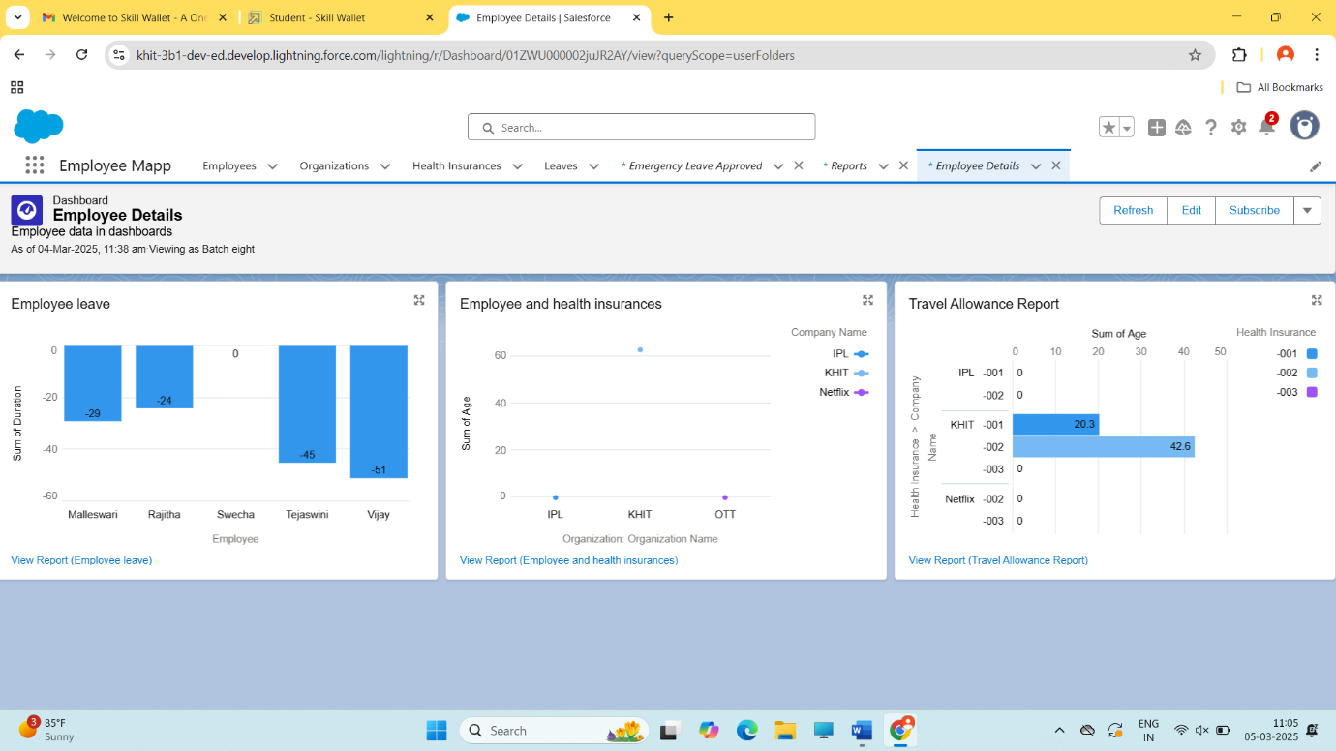

**5. Testing and Validation**

**Create a Class in Apex**

1. Then you can see many tools in the Toolbar of the new console window. Click on File, New and Apex Class.
2. Enter the name “LeaveTriggerHandler” click ok.
3. Enter the given code in the console.

public class LeaveTriggerHandler {

public static void ifMaleEmployee(List<Leave__c> leaveRequests) {

              // Fetch employees related to leave requests

              Set<Id> employeeIds = new Set<Id>();

               for (Leave__c leaveRequest : leaveRequests) {

               if (leaveRequest.Employee__c != null) {

               employeeIds.add(leaveRequest.Employee__c);

            }

        }

// Fetch employee records

        Map<Id, Employee__c> employeesMap = new Map<Id, Employee__c>([SELECT Id, Gender__c FROM Employee__c WHERE Id IN :employeeIds]);

        // Check eligibility for maternity leave and gender

        for (Leave__c leaveRequest : leaveRequests) {

            if (leaveRequest.Leave_Type__c == 'Maternity Leave') {

                Employee__c emp = employeesMap.get(leaveRequest.Employee__c);

                if (emp != null && emp.Gender__c != null && emp.Gender__c == 'Male') {

                    leaveRequest.addError('Male employees are not eligible for Maternity Leave');

                }

            }

        }

    }

}

1. Check for errors and save it.

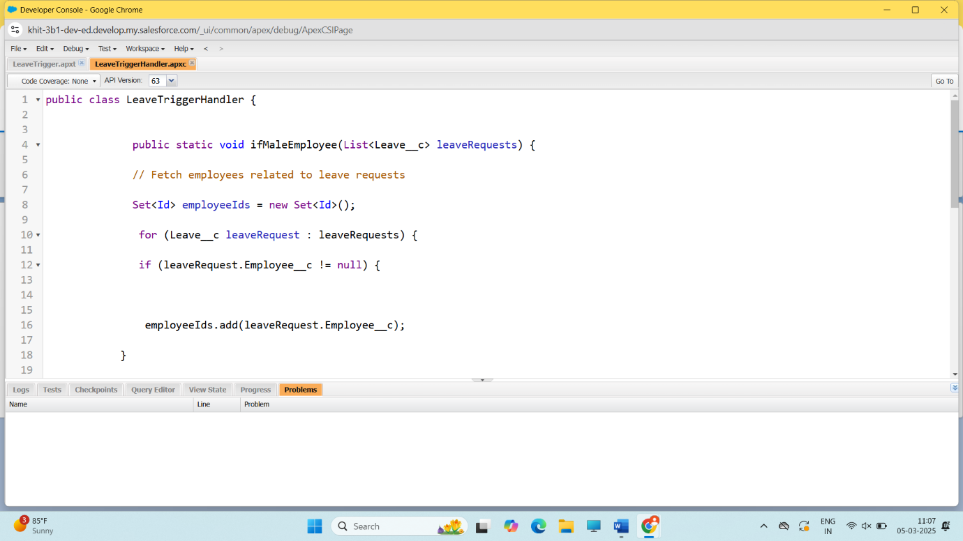

**Create a trigger in Apex**

1. Login to the Developer account and navigate to the gear account in the top right corner.

2. Then we can see the Developer console. Click on the developer console and you will navigate to a new console window.

3. Then you can see many tools in the Toolbar of the new console window. Click on File, New and Apex Trigger.

4.  Enter the name “LeaveTrigger” select the sObject from the list “leave__c”.

5. Enter the given code in the console, check for errors and save.

trigger LeaveTrigger on Leave__c (before insert) {

 if(trigger.isBefore){

  if(trigger.isInsert){

    LeaveTriggerHandler.ifMaleEmployee(trigger.new);

       }

     }  
 }

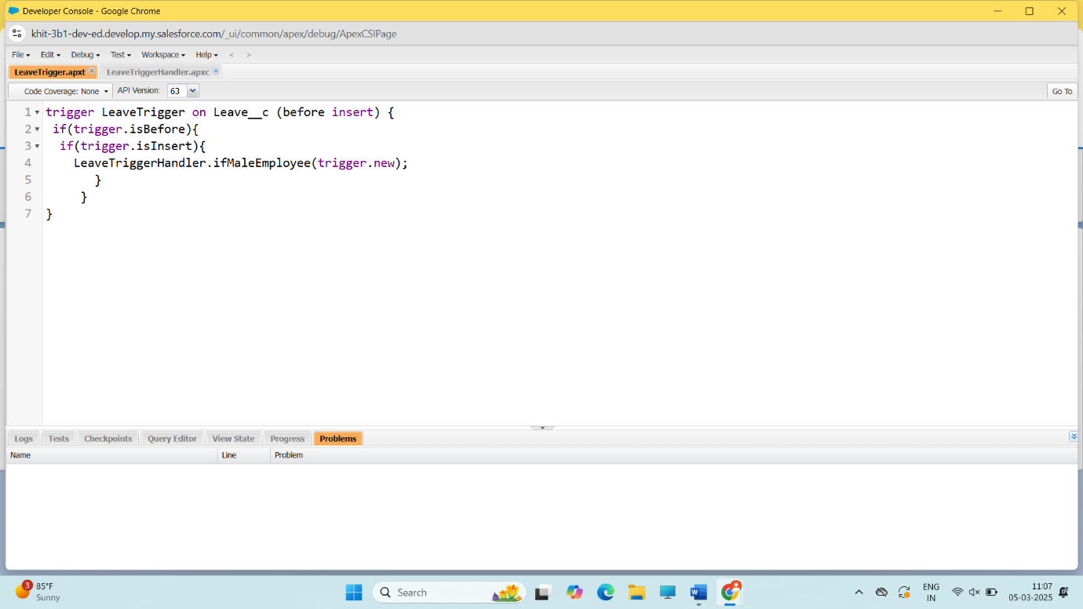

**6.Key Scenarios Addressed by Salesforce in the Implementation Project**

**Scenario 1: Employee Onboarding**

1. Automated workflows: Salesforce automates the onboarding process, assigning tasks and sending notifications to relevant teams.

2. Customizable onboarding templates: Salesforce provides customizable templates for onboarding, ensuring consistency and accuracy.

3. Integration with HR systems: Salesforce integrates with HR systems, such as Workday or BambooHR, to streamline data transfer.

**Scenario 2: Employee Data Management**

1. Centralized employee database: Salesforce provides a single, unified database for storing employee details, ensuring data accuracy and consistency.

2. Real-time data updates: Salesforce enables real-time data updates, ensuring that employee information is always up-to-date.

3. Customizable fields and objects: Salesforce allows for customizable fields and objects, enabling organizations to capture unique employee data.

**Scenario 3: Managerial Tasks and Approvals**

1. Automated approval workflows: Salesforce automates approval workflows, streamlining managerial tasks and ensuring timely approvals.

2. Customizable approval processes: Salesforce allows for customizable approval processes, enabling organizations to define unique approval workflows.

3. Real-time notifications: Salesforce provides real-time notifications, ensuring managers stay informed about pending approvals and tasks.

**Scenario 4: Reporting and Analytics**

1. Customizable reports and dashboards: Salesforce provides customizable reports and dashboards, enabling organizations to track key metrics and KPIs.

2. Real-time analytics: Salesforce enables real-time analytics, providing insights into employee data, managerial tasks, and organizational performance.

3. Integration with external systems: Salesforce integrates with external systems, such as HRIS or payroll systems, to provide a comprehensive view of organizational data.

By addressing these key scenarios, Salesforce provides a comprehensive solution for streamlined employee detail management, enabling organizations to improve data accuracy, increase efficiency, and enhance employee experience.

**7.Conclusion**

Streamlined Employee Detail Management using CRM is a comprehensive and efficient system designed to effectively manage and organize employee information within an organization. This system leverages Customer Relationship Management (CRM) principles and tools to centralize and streamline employee data, providing a robust platform for HR professionals and managers to handle various aspects of employee details.